**5 MINUTE OFFICE WORKOUT**

It can be hard to fit in time to exercise when you have a busy home and work life, but it’s so important for our health and wellbeing to move our bodies. Taking just five minutes out of your day to get active can boost your concentration, prevent that afternoon slump and energise you for the rest of the day.

Below are some easy exercises to do at your desk which will work your full body and require no equipment. They will help mitigate any muscle aches and pains you get from sitting all day, as well as strengthening muscles that we need for good posture and preventing injury.

Squats

Start with your feet hip width apart

Hold your arms out in front of you or cross them across your chest

Imagine there is an invisible chair behind you and bend your knees so that your thighs are parallel to the ground

Push through the heels and squeeze your bottom to stand back up making sure your knees don’t roll inwards

Repeat 10 times

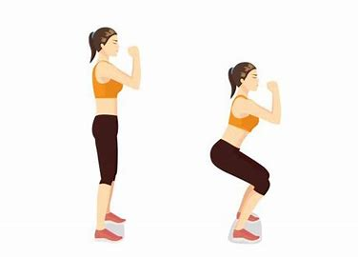

Calf Raises

One of the simplest exercises you can do

Stand up tall, push through the balls of your feet until you are on your tiptoes and then lower your heels back down again

Repeat 10 times

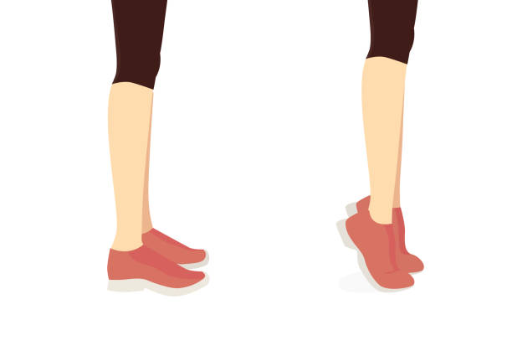

Triceps Dips

Stand in front of your chair and hold the front with your hands keeping your shoulders down

Keep your hips and knees at 90 degrees and slowly lower your bottom towards the floor by bending your elbows until your arms are at a 90 degree angle

Pause at the bottom and straighten your elbows again leaving a small bend so they don’t completely lock straight

Made it harder by straightening out your legs and resting on your heels

Repeat 10 times

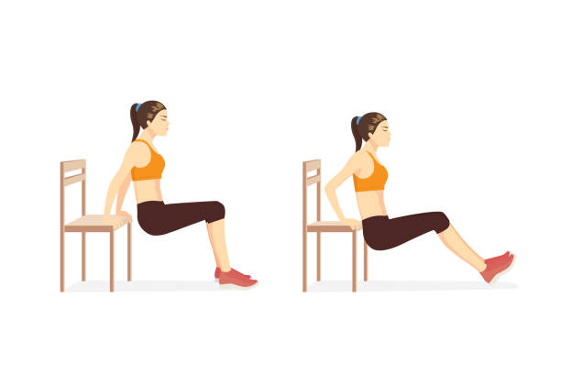

Desk/Chair Push Ups

Using either your desk or your chair place your arms as wide as you would like – the farther apart they are, the harder it will be

Start with your feet hip width apart – bringing them together will make it harder

Bend your elbows lowering your chest towards the desk or chair, hold for a second then straighten your elbows out taking care not to lock them straight

To make it easier you can start on a wall instead of your desk or chair

Repeat 10 times

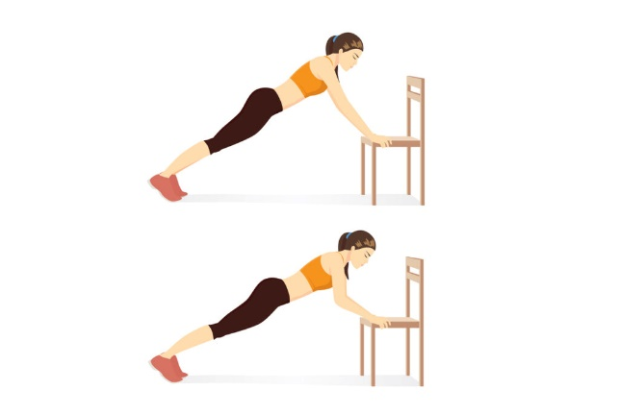

Abdominal Twists

Sit on the front edge of your chair or desk and lean back to 45 degrees

Lifting your feet off the floor will make this exercise harder

Clasp your hands together and twist to the left touching the left edge of the chair with your hands then return to centre. Repeat on the right side

Repeat 5 times each side

